AMTE Proposal Reviewer FAQs

Q: How do I access my assigned reviews?
A: The review system is located at https://convention2.allacademic.com/one/amte/amte22/ You will need to log in with the username and password you created for All Academic when you volunteered to review for this year’s conference. This is not necessarily the same as your username and password for the AMTE website.
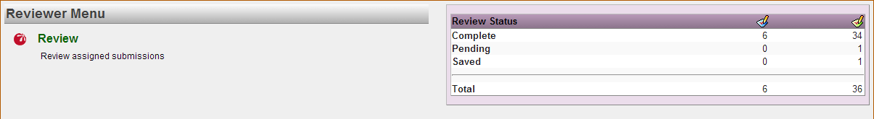

Q: How much time do I have to complete my reviews?
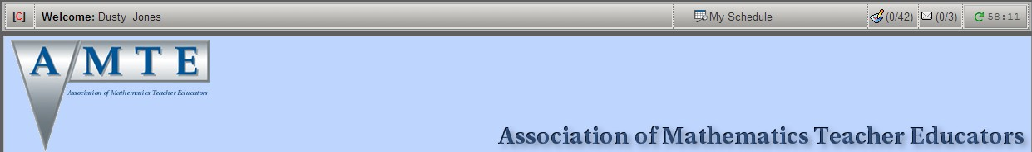
A: The deadline to submit your reviews is June 15. Additionally, you may notice a timer in the upper right-hand corner of the All Academic website. The system will allow you to be on a page for one hour, afterwards it will log you out of the system. The timer resets to 60 minutes when you move to a new page.

Q: Must I complete my reviews online?
A: Yes, all reviews must be entered using the All Academic system. At the same time, we recommend that you type your comments that will be part of your reviews in another document and paste them into the appropriate fields. This affords you the ease of using the features of your favorite word processor (such as spelling and grammar check) and helps to avoid “timing out” on the website.

Q: I accidentally pressed the “back” button on my browser. What should I do?
A: Remain calm. The system was not designed to keep track of a large amount of information, so it does not allow backtracking. If you receive an error message, try clicking the “forward” button on your browser. If that doesn’t work, log into the system again. Be sure to check and see if the work you completed before pressing “back” is still there.

Q: What guidance is there for assigning a numerical rating for the review criteria?
A: You will be asked to give a numerical rating (an integer from 0 to 3, inclusive) for the following review criteria:
- Presentation Goals - To what extent does the proposal describe goals for the session that are appropriate for an AMTE audience, including what participants may have the opportunity to learn by participating in the session?
- Relationship to AMTE’s Mission - To what extent is the proposed topic related to AMTE’s mission to promote the improvement of mathematics teacher education, K-12?
- Connection to Research or Theory - To what extent does the proposal include connections to existing research or theoretical perspectives?
- Connection to Practice - To what extent does the proposal indicate evidence of informing the practice of mathematics educators?
- Engagement & Plan for Session* - To what extent does the proposal describe a well-planned session that actively engages participants?
- Quality of Ideas - To what extent does the proposal describe high-quality ideas

* Note: Research Report and Poster proposals will not be reviewed for Presentation Engagement or Presentation Organization.

A description of ratings 0 and 3 is provided for each criterion on the review form; Below is an example for the Presentation Goals criterion.
0: The proposal does not provide appropriate goals for an AMTE audience.
3: The proposal clearly describes high-quality goals that are appropriate for an AMTE audience.

Q: Does AMTE prefer sessions that focus on results from research?
A: AMTE encourages proposals of many types, such as those that focus on best practices in teaching, those that report findings from research, and those that provide forums for rich discussions on a current topic of interest. Hence, the reviewer should keep in mind that not all proposals will fit into the same mold. This is one reason that there are criteria for connections to both research or theory and to practice. Both are important.

Q: I read a proposal that mentions Project X in STATE University, and cites Author (date). What is going on?
A: Proposal authors were asked to blind any identifying information to protect the integrity of the review process. Therefore, you may find evidence that some proper nouns have been replaced with ambiguous referents. If these proposals are accepted onto the program, the blinded components of the title or description will be replaced with the actual information.

Q: How do I access the reviewer form?
A: Under each tab on the review assignments page, you can see the title and All Academic code for each proposal, as well as the status of each review (Pending, Saved, or Complete). To access a pending or saved review, click the green “Review” link to the right of the proposal title. This will bring you to a page with information about the proposal, and you may download the proposal by clicking the green link.

Below the “Session Submission Summary” window, you will find the review form, with drop-down menus for rating the proposal according to the listed review criteria. You are also given space to write comments to the author and comments to the Association. These are both required fields.

Q: Are comments to the Association and comments to the author necessary?
A: Yes! This is one of the most helpful actions you can take as a reviewer. These are especially necessary for explaining lower ratings. The Conference Program Committee will consider your comments and numeric ratings together as they determine which proposals are recommended for inclusion on the program.

Q: What sorts of comments should I make?
A: Your comments should support the ratings that you provided, especially in the case of lower ratings. In general, every proposal has at least one aspect that is positive and at least one way it could be improved. Some guiding questions for reviewing proposals:
- What makes this proposal stand out?
- Is a key piece of information missing from this proposal?
- Would this presentation be interesting to members of AMTE?
- Does the proposal describe a workable plan for engaging the audience?
- How closely does the proposal match the selected strand?
- If this proposal is presenting research, how strong is the research framework?
- Do the authors overstate or over-generalize results?

Q: What specific advice do you have for making comments to the Association?
A: – Be very blunt and specific in comments to the Association. The author will not see the comments entered in this field.
- Although you would never tell an author, "This proposal is extremely weak and definitely should be rejected. The methods do not match the research question and the findings are overstated. The stated plan for session time would be very unappealing/boring to an audience," such a comment is appropriate for the Association.
- The Conference Program Committee has to be able to rank proposals and determine which to recommend for inclusion in the program. Very blunt and specific comments make it much easier to make such decisions.
- Avoid generalizations such as "great" or "bad." Instead, be very specific about what makes the proposal great or bad.

Q: What specific advice do you have for making comments to the author?
A: – The author will receive these comments. Because of this, the reviewer serves as a sort of “anonymous” representative of AMTE.
- Be very constructive in the comments to authors. Think about whether you would want to read a comment like that about your own work. Try to make two positive comments for each negative comment.
- Be very specific for negative comments, not vague (be specific for positive comments, too). If a proposal is not accepted, the author should be able to read specific comments for this reason. For example, "poor grammar" is vague, while "numerous issues with subject/verb and noun/pronoun agreement" is more specific.

Q: It appears that I still have reviews pending. Where can I find them?
A: There are a couple of places on the site that inform you if you have reviews pending.
The first is on the “Reviewer Menu” which is shown after you log in.

After you click the green “Review” link, you will arrive at the Review Assignments page. This contains some instructions, followed by a table of statistics that lists how many proposals you have pending, and how many you have completed.
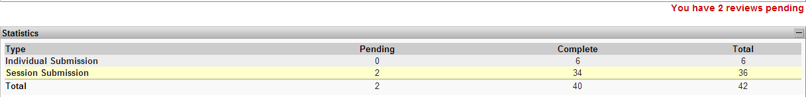

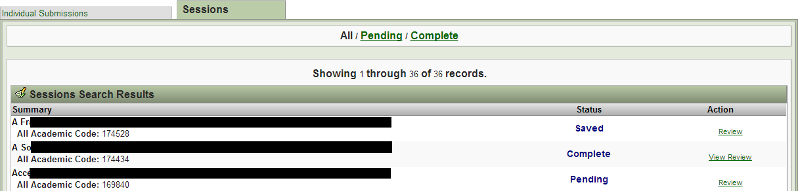
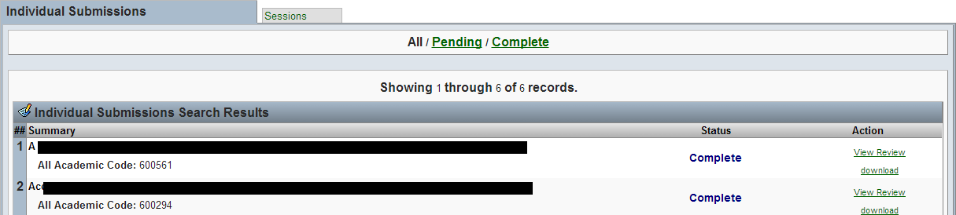
The All Academic system sorts all proposals into two categories, called “Individual Submissions” and “Session Submissions.” AMTE Research Reports and Posters are all gathered into the “Individual Submissions” category. All other session types are in the “Session Submissions” Category. You will need to click on the tab for each category to view your assignments.

Q: What if my question was not listed here, or if it was not answered to my satisfaction?
A: Please contact the Conference Program Chair with your question.

