Image of Exit Ticket Candidate Response-Evaluated

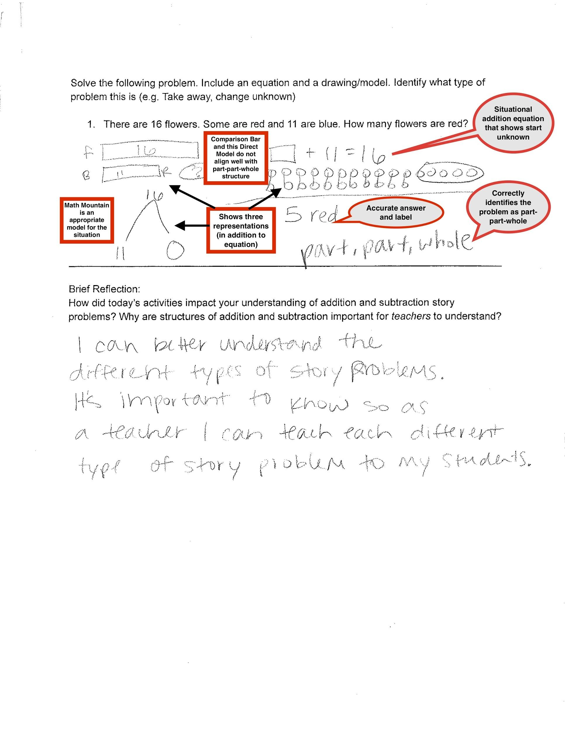

Rubric for Exit Ticket Candidate Response-Evaluated

|  |  |  |  |  |  |
| --- | --- | --- | --- | --- | --- |
| Structure | Add to/Join | Take away/ Separate | Put together/take apart/part-part-whole | | Compare |
| Unknown location | Total unknown | Change unknown | Start unknown | Addend/s unknown | Difference Unknown |
| Nature of equation/s | Solution equation | | Situation equation | Both | Neither |
| Operations | Addition | | Subtraction | Both | Neither |
| Total location | Total on left of equal sign | | Total on right of equal sign | Both | Neither |
| Representation number | Zero | One | Two | Three | Four or more |
| Representation type | Direct model | Math mountain | Bar model | Comparison bar | Multiple |
| Accuracy | Both answer and label are accurate | | Answer OR label are accurate | | Neither are accurate |