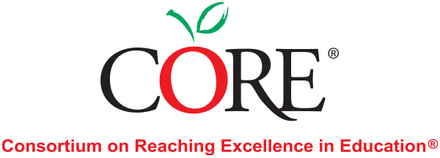
CORE Math® Consultant
Position Description

About the Organization
The Consortium On Reaching Excellence in Education (CORE) provides expert technical assistance and professional development for K-12 literacy and mathematics programs. Our evidence-based-model supports the implementation of Common Core State Standards and all other state standards in English Language Arts and Mathematics. We work with educators and administrators at all grade levels, district personnel, and state departments of education to build system-wide capacity for sustained improvement.

About the Position
We are currently searching for new CORE Math® Consultants to add to our pool of consultants, ready to be assigned to client projects as needed. Potential consultants must be available a minimum of 20 hours per month, and up to 40 hours per month. Once added to CORE’s consultant pool, projects will be assigned as opportunities are finalized with our clients. Note that this work will not involve a consistent schedule; typical client engagements involve multiple 3-day trips to the client site, scheduled throughout the school year.
CORE Math® Consultants provide professional development services in mathematics, traveling to client sites to deliver a range of services. CORE’s services may involve providing on-site consultation on effective math instruction and program implementation including but not limited to providing demonstration lessons, classroom observations and feedback, side-by-side teaching and coaching, RTI support, supporting school or district administrators and coaches, and assisting with implementation plans. You may also periodically provide PD in a workshop setting using CORE presentation materials.
We are looking for an elementary, a combined elementary and middle school, or a middle/high school educational contractor with at least 5 years mathematics teaching experience with K-5, K-8, or 6-12 respectively. Two or more years of experience as a math coach or instructional leader is also required.
CORE Math® Consultants must be available to travel to school and district sites nationwide.

Qualifications
- BA/BS degree required. Master’s degree in mathematics or math education, or specialist credential preferred especially if you are applying to work with grades 6-12.
- At least 5 years of math teaching experience is required within the grade bands for which you are applying to work. In addition, two or more years’ experience as a math coach, instructional leader/ consultant, providing professional learning services to teachers and administrators, is also required.
- Strong foundational knowledge in evidence-based mathematics instruction and research on teaching mathematics.
- In-depth knowledge of the Common Core State Standards for Mathematics and/or other state standards.
- Knowledgeable about effective skills and strategies for diverse learners and non-native English speakers.
- Demonstrated ability to conduct and facilitate effective presentations which include responsiveness, flexibility, and the ability to exercise good judgment. Ability to communicate effectively with diverse audiences.
- Demonstrated knowledge of a wide range of programs and publisher materials, including math intervention programs and mathematics assessments is preferred.
- Experience in a variety of school settings serving diverse populations is preferred.
- Able and willing to travel, including to remote locations.
- Knowledgeable in Microsoft suite of products, internet resources is a plus.

Compensation & Benefits
CORE Math® Consultants are compensated on a per diem basis for each assignment. This is an independent contractor/1099 role, and no benefits are provided.

Application
If you would like to apply, please submit a letter of interest and resume to HR@Corelearn.com and include “Math Consultant” in the subject line of your email.

