**Developing the Ability to Respond to Student Thinking**

Goals for this assignment:

1. Develop a variety of strategies (e.g., alternate tasks, review, questioning) for responding to student’s thinking in order to further their understanding of a mathematical concept.
2. Become aware of the power of carefully chosen questions in eliciting and developing student’s mathematical thinking and reasoning as well as moving students to a higher level of understanding.
3. Practice developing questions that will help elicit and develop student’s mathematical thinking in response to student work.
4. Consider the importance of holding back from telling students something they could work out for themselves.
5. Reflect on ways of responding to students’ thinking.

Student learning objectives for the task:

1. Students will be able to solve systems of equations through multiple representations.
2. Students will be able to explain in multiple ways (verbally, symbolically, and graphically) the significance of having two equations set equal to one another and the meaning of the solutions. (Students may also use a table to explain their thinking)

**Part One**: **Responding to Student Work**. Given the accompanying student work samples from previously conducted interviews, write your responses to the following prompts for each student sample:

* + What concepts does the student understand and/or what procedures can the student do?
  + Do you need to ask questions of the student to help you understand what this student is thinking? If so, what question(s) would you ask and why? If not, what response would you give to the student?

Recall the 4 characteristics of a good response

1) Works towards student learning objective.

2) Draws on and is consistent with the student thinking presented.

3) Draws on and is consistent with research on students' mathematical development.

4) Proposed interaction with student leaves space for student's future thinking (not just teacher's thinking)

* + Does your response help to elicit and develop the student’s thinking with the learning objectives in mind? In what ways?
  + Does your response build on the student thinking that is evident in the written and/or transcribed work? How?
  + Does your response build on what you know about the learning of solving linear equations? How?
  + Are you telling students something they could work out for themselves? If so, why? If not, how are you leaving space for the student to think on his/her own?

**Part Two: Reflecting**. Answer the following reflection prompts:

How has the in-class instruction and this take-home assignment improved your ability to respond?

How do the responses you craft now differ from those you gave prior to this instruction on responding?

What strategies do you use to develop your responses?

What implications does learning how to notice and respond to student thinking have for you in your future work with students?

**SAMPLE A: MARK [solving problem B]**

Yeah, okay. So, for, so I want to get rid of this 2. That’s like on the side, so I’ll divide this whole other side by 2. I’m dividing the other side by 2 also to get rid of the 2. So then I get 3x plus 4 equals 3x plus 4. Because you divide 6 by 2 and 8 by 2. So then I can just subtract 4 from 4 which is 0 and subtract 3x from 3x which is zero. So… x = 0? Right? Cause you just divide 0 from 0, so x = 0?

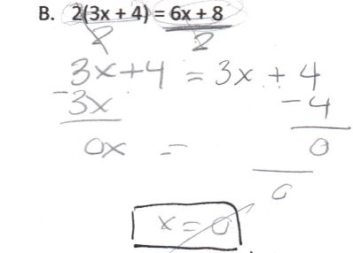

**SAMPLE B: MARTHA [solving problem C]**

Um, so I wanted to get the x’s on one side and so I subtracted six x from both sides. Then I…then you had to get all of the constants on one side so I added five to both sides. Then I got eight plus five equals six x minus six x, and so I got thirteen equals x.

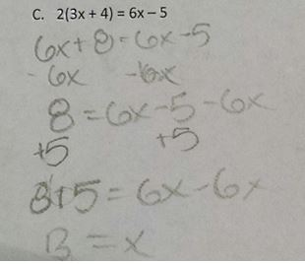

**SAMPLE C: LAQUISHA [solving problem C]**

LaQuisha: So, I wouldn’t want to divide this by 2, cause 5 divided by 2 is kinda, kind of messy, so I think I’ll just do the distributive property again. 6x +8 = 6x-5, yup. And then, minus 8. Well, actually- if it’s a minus 8, I can just add 5, that’s easier. 6x +13 = 6x. Umm, minus 6x, minus 6x, so it’s just 13 = 0, so that’s…Either I did it wrong, or that’s just not equal to something. Or I could’ve…(concentrates)….Yeah.

Interviewer: So, is this your solution? (points at ‘13 =0’)

LaQuisha: Umm, kind of (LaQuisha then draws a line through the equals sign to indicate 13 does not equal 0).

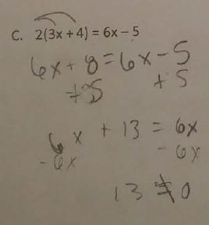

**SAMPLE D: TRISHA [solving problem B]**

Okay. Alright, so, I’m going to begin by… um… multiplying this parenthetical equation here, so it becomes…8…interesting. [laughs] Okay. Well, that’s obvious… [Looks at her result, which is 6x = 6x, for about 30 seconds.] Okay…Well, this one is confusing me, because they’re equal on either side now, so… um… x is… 1? Or…?... I don’t know. It’s fooled me.

**SAMPLE E: ZANDER [solving problem A]**

Interviewer: What are you thinking as you’re doing that part? 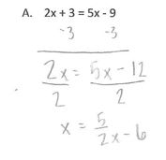

Zander: To get x by itself, but then there is another x over here.

Interviewer: So is x by itself?

Zander: This one is [points to left side of equation], but not this one

[points to right side of equation].

Interviewer: Why not?

Zander: Because it’s (5/2)x – 6 and I don’t know how to get rid of them.